PRN – 260245920034

- List names of employees whose job is MANAGER.
mysql> select ename from emp where job = 'Manager';

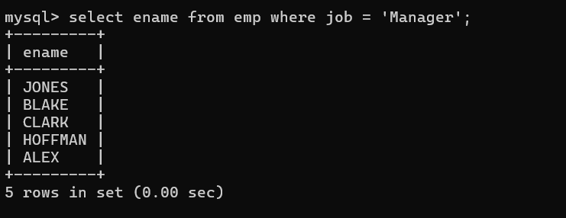

- List names of employee having salary greater than equal to 3000.
mysql> select ename from emp where sal>=3000;

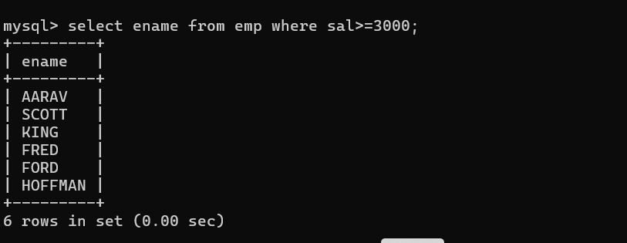

- List all employees having ‘A’ as second letter in their names.
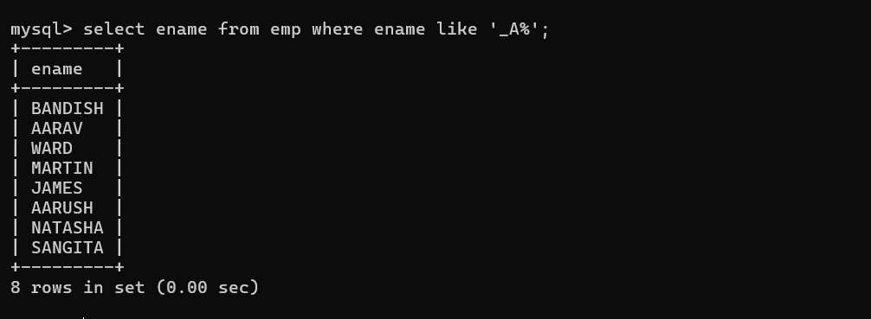
mysql> select ename from emp where ename like '_A%';

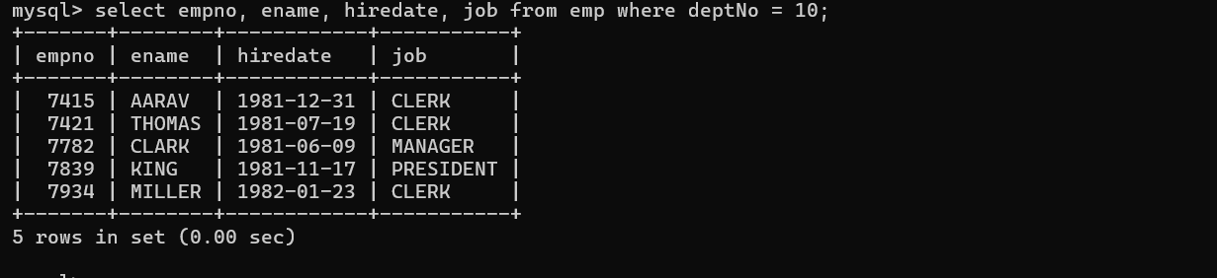
- List the Employee Number, Name, Hiredate and Job Title of the Employees in the Department 10.
mysql> select empno, ename, hiredate, job from emp where deptNo = 10;

- Display the details of those Employees who earn a monthly Salary of more than 2000.
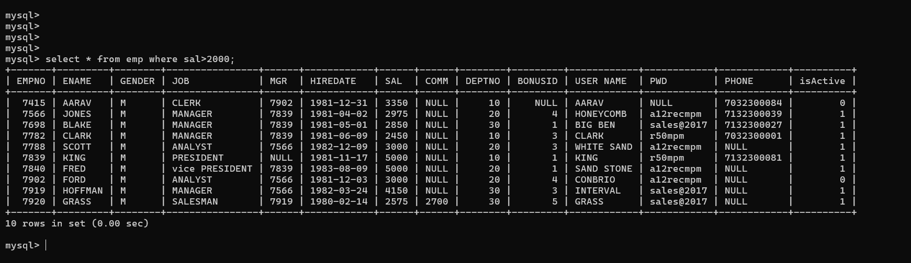
mysql> select * from emp where sal>2000;

- Display the names of all Employees from Department 10 and 20 whose name start with “A” and ends with “B”. mysql> select ename from emp where deptno in (10, 20) and ename like 'A%B';
Empty set (0.00 sec)

- Display the details of the employees who have joined on 21-DEC-1990.
mysql> select * from emp where hiredate = '1990-12-21';
Empty set (0.00 sec)

- Display the Employee Code, Name, Job & Annual Salary for all Employees belonging to Department Number 10.
mysql> select empno as EmployeeCode, ename as Name, job as JobTitle, sal * 12 as AnnualSalary from emp where deptno = 10;

- Display the details of the Employees who earn an Annual salary of more than 25000. Sort the records in the descending order of Salary.
mysql> select * from emp where sal * 12 > 25000 order by sal desc;

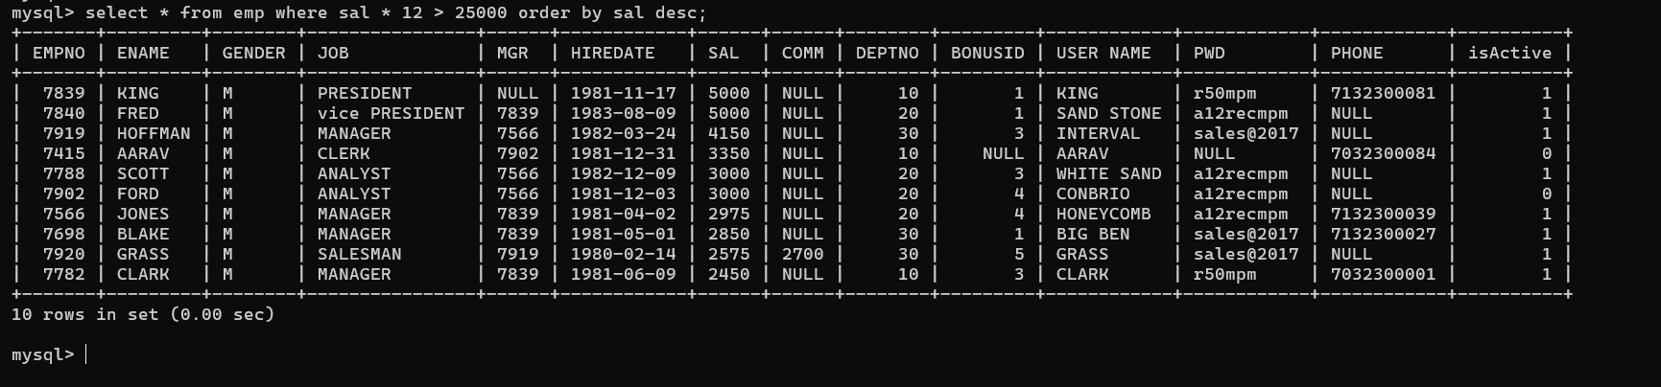

- Display the names of Employees whose names contain the character “F”.
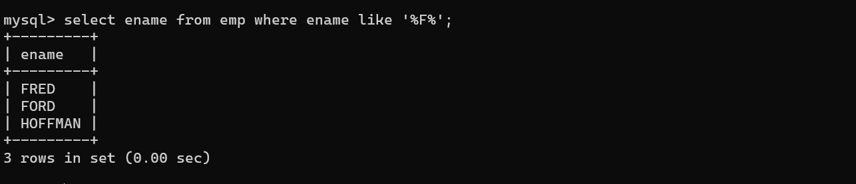
mysql> select ename from emp where ename like '%F%';

- Display the Employee Code, Name, Job & Annual Salary for all Employees belonging to Department Number 10.
mysql> select empno as EmployeeCode, ename as Name, job as JobTitle, sal * 12 as AnnualSalary from emp where deptno = 10;
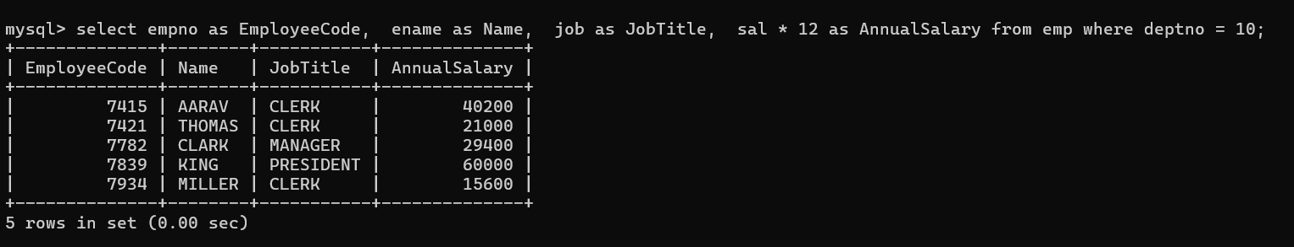

- Display the details of the Employees who earn an Annual salary of more than 25000. Sort the records in the descending order of Salary.
mysql> select * from emp where sal * 12 > 25000 order by sal desc;
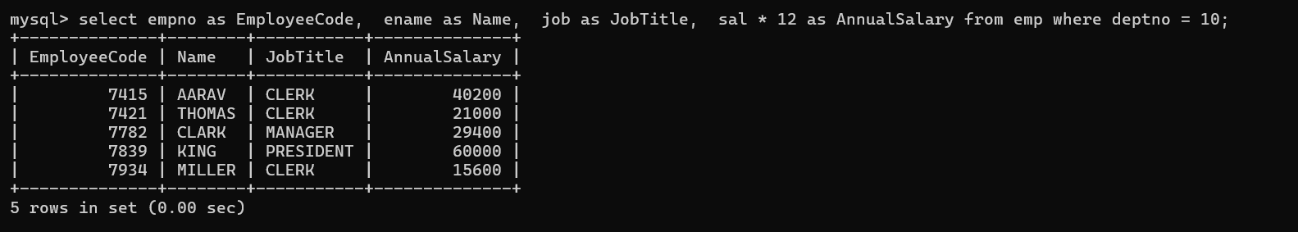

- Display the names of Employees whose names contain the character “F”.
mysql> select ename from emp where ename like '%F%';
+---------+
| ename |
+---------+
| FRED |
| FORD |
| HOFFMAN |
+---------+
- rows in set (0.00 sec)

- Display the Names and Numbers of all Departments in the descending order of the Department Names.
mysql> select dname, deptno from dept order by dname desc;

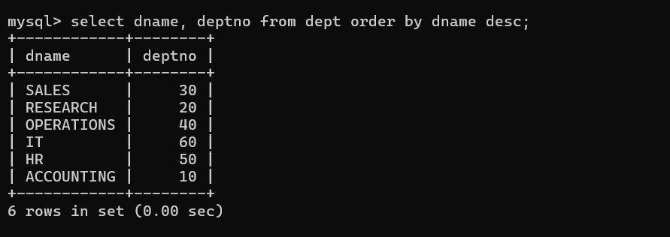

- Display the Name, Employee Number, Designation and Salary of those Employees who earn a monthly salary of not less than 1000 and not more than 2000.

mysql> select ename as Name, empno as EmployeeNumber, job as Designation, sal as Salary from emp where sal between 1000 and 2000;

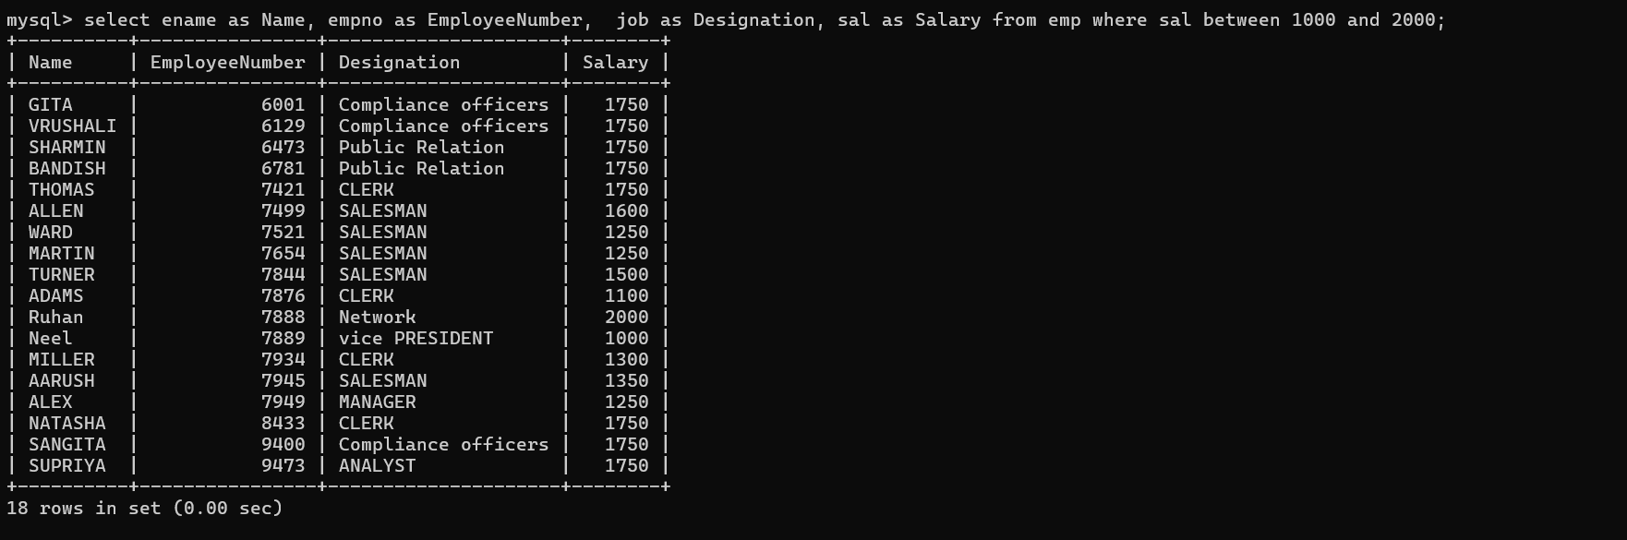

- Find out the Bonus (Bonus 1.1% of Annual Salary) that every person will receive at the end of the year.
select empno as EmployeeCode,
ename as Name,
job as Designation,
sal * 12 as AnnualSalary,
sal * 12 * 0.011 as Bonus
from emp;
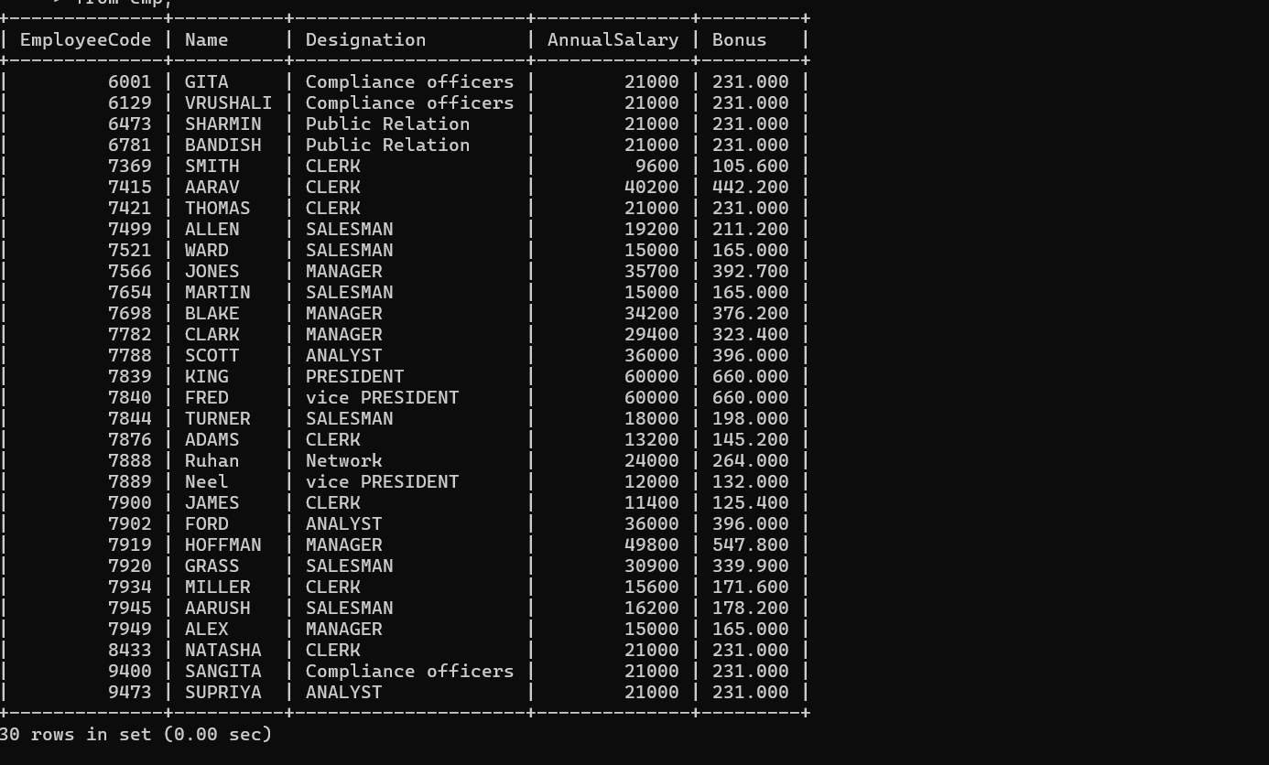

- Display the Name, Job and Dept No. of all the Employees who either work in Department 30 or in Department 40.
select ename as Name,
job as JobTitle,
deptno as DepartmentNumber
from emp
where deptno in (30, 40);
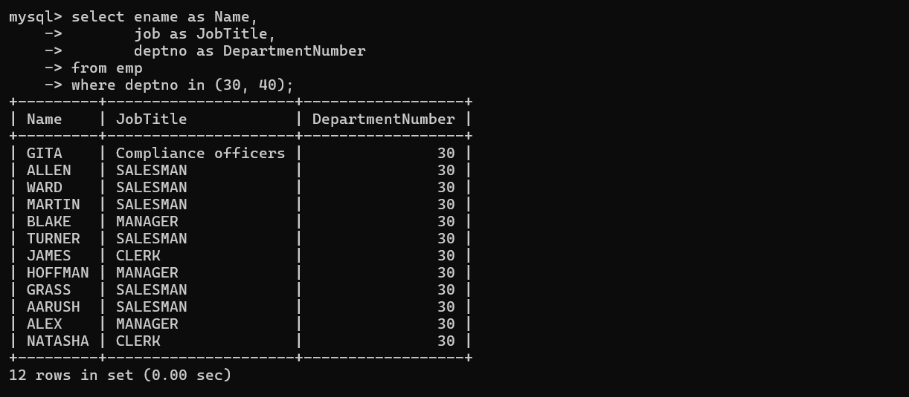

Q. 18. Display the Employee Number, Name for Clerks and Managers who’s Salary is more than 1500.
mysql> select empno as EmployeeNumber,
-> ename as Name
-> from emp
-> where job in ('CLERK', 'MANAGER')
-> and sal > 1500;
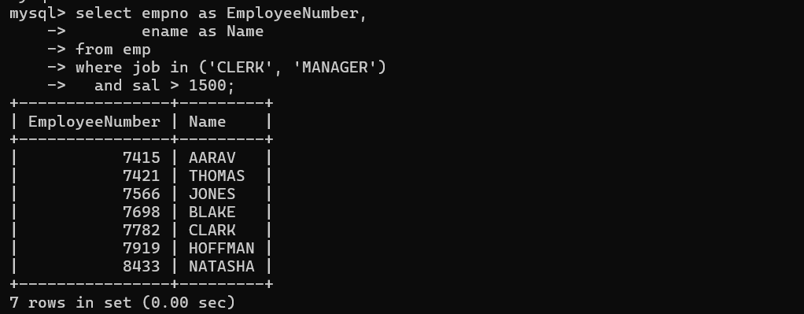

Q. 19 Display the Name, Annual Salary and Commission as “Commission Earned” of all employees whose monthly
salary is greater than their Commission. The output should be in decreasing order of salary. If two or more
employees have same salary, then sort them by name within the highest order of salary.
select ename as Name,
sal * 12 as AnnualSalary,
comm as "Commission Earned"
from emp
where sal > comm
order by sal desc, ename asc;
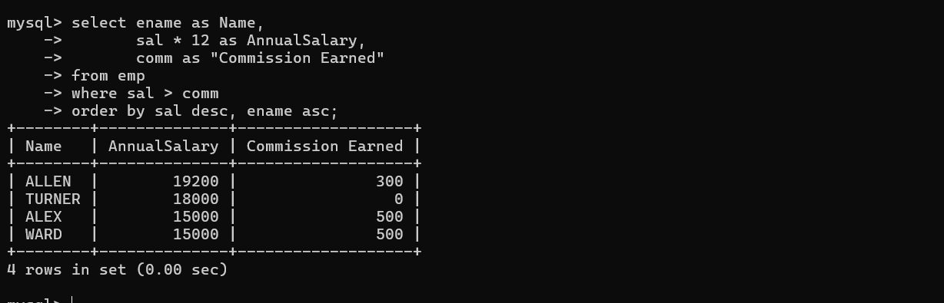
20. Display the Name and Job of sales executives or managers whose names end with the letter ‘S’.
select ename as Name,
job as JobTitle
from emp
where job in ('SALESMAN', 'MANAGER')
and ename like '%S';
